Medical Practice Initial Report

Red Opal Innovations

Version 1

Table of Contents

Overview 3

The business domain of the medical practice 3

1. Business Requirements of the medical practice 3

Technologies and applications 9

Version control 11

Client Meeting 11

Interview 11

2. Database design 12

Chen Entity Relationship Diagram (Chen ERD) 12

Relational Data Model (RDM) 13

Data dictionary 16

Crow’s Foot Entity Relationship Diagram (CF ERD) 20

3. Validate data model 21

Interview 21

4. Resolve issues 22

Database development Plan 22

Normalization 23

Email to co-worker 24

# 

# Overview

[Red Opal Innovations](https://share.tafensw.edu.au/share/items/73f2bb48-c457-4fe9-96cf-618ee5f5f2bc/0/?attachment.uuid=2bbeb148-09a8-4884-871c-c95138fe38bf) (ROI) is an information technology company, as a ROI database developer my task is to design, develop and test the database for a new Medical Practice Management system.

The business data and business rules are already defined by a business analyst after a thorough investigation of the day-to-day operations of the medical practice. This document along with the organisation’s Communication and Records Management procedures are supplied.

The Medical Practice offers general medical services by doctors and other services such as physiotherapy, podiatry, optometry, etc.

# The business domain of the medical practice

The Medical Practice offers general medical services by doctors and other services such as physiotherapy, podiatry, optometry, etc.

The key stakeholders include the practitioners, nurses, receptionists, and patients.

Details of pathology tests requested by practitioners for patients must be recorded, details include the type of test, the date and time that test was requested, and details of the practitioner requested the test. Pathology tests could be requested at any time.

The Medical Practice is open from Monday to Friday from 8:00 am till 6:00 pm and the practitioners are available at the Medical Practice on varying days of the week.

Patients must be able to book appointments to see practitioners through receptionists, the database is required to provide tracking information of patients, and any pathology tests that the patient may be required to undertake.

# Business Requirements of the medical practice

### System boundaries

The system interacts and captures information about these people and objects:

* Customers(patients)
* Receptionist
* Pathology tests
* Practitioners
* Appointments

The system will support these following business process:

* Medical services
* General health screening services
* Pathology tests
* Appointment management

### The impact of the business rules on the entities and relationships

The Medical Practice is open from Monday to Friday from 8:00 am to 6:00 pm and the practitioner’s availability at the Medical Practice varies during the week. For instance, one of the nurses is only available on Tuesdays, Wednesdays, Thursdays while the podiatrist is available on Mondays and Thursdays of each week.

The practitioners’ availability does not change from week to week and they’re available for the whole day, 8:00 am till 6:00pm, on the days that they work.

Tracking information of patients’ appointments with practitioners, and any pathology tests that the patient may be required to undertake, needs to be provided by the database.

### Business rules that apply to patients:

The information to be stored for each patient are shown in the diagram

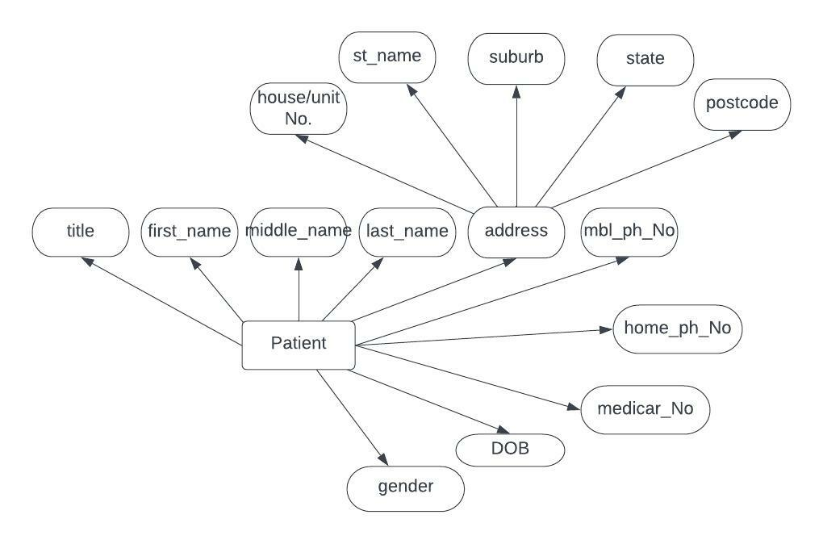

­All addresses in the database must be within Australia.

Only the patient’s current details have to be stored.

Only the Medicare Number field could allow null values.

Patient’s records cannot be deleted.

### Business rules that apply to Practitioners:

The information to be stored for each patient includes their title, first name, middle initial (if applicable), last name, house, unit or lot number, street/road name, suburb, state, post code, home phone number (if applicable), mobile phone number (if applicable), Medicare number (unique), Australian health practitioner regulation agency (AHPRA) medical registration number (MRN) (unique), date of birth, gender, practitioner type, days of the week available.

These details must be updatable, and only current details must be stored.

No practitioners can be without an AHPRA Medical Registration Number (MRN) and a practitioner can only practise under one Registration (one practitioner type) with the Australian Health Practitioner Regulation Agency (AHPRA).

Types of practitioners:

* Medical practitioner (Doctor or GP)
* Medical radiation practitioner
* Diagnostic radiographer
* Radiation therapist
* Nurse
* Registered nurse
* Enrolled nurse
* Midwife
* Occupational therapist
* Optometrist
* Osteopath
* Physiotherapist
* Physical therapist
* Podiatrist
* Psychologist.

### Business rules that apply to Appointments:

In addition to the date and start time of the appointment, for each appointment the following information must also be stored:

* The information to be stored about the patient that is making the appointment includes their title, first name, surname and date of birth.
* The information to be stored about the practitioner with whom the appointment is to be held includes Title, first name, surname, and type of practitioner.

The system must store details of both past and future appointments.

Each appointment is given 15-minute increments commencing on the quarter hour. For example, an appointment could start at 09:00 am and finish at 09:15 am. Or, for a more complex consultation

an appointment can begin at 10:00 am and finish at 10:45 am. In this case, two 15-minute appointments are booked.

An appointment can only be made with a practitioner if they’re available on the day of the desired appointment.

Patients must be able to make an appointment to see any of the practitioners.

A patient must not be allowed to book more than one appointment on the same date and commence time.

A practitioner is not allowed to take more than one appointment on the same date and start time.

### Business rules that apply to Pathology tests:

Details of pathology test code, test name and its description must be stored in the database.

Details of pathology tests requested for a patient by a practitioner must be stored in the database, the information to be stored includes type of pathology test, the date and time that the test was ordered, practitioner that ordered the test, the patient for whom the test was ordered, and a practitioner will not be allowed to request a pathology test for a patient on the same date and time.

### Context diagram

The system boundaries include:

* Customers(patients)
* Receptionist
* Pathology tests
* Practitioners
* Appointments

The context diagram bellow helps to understand the boundaries of the system.

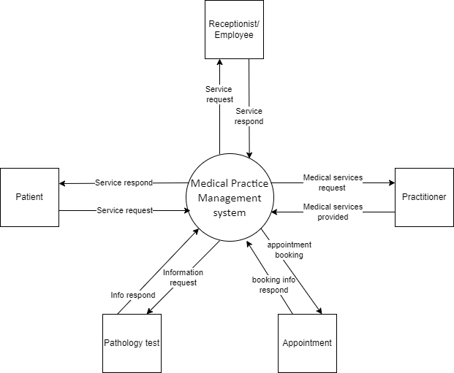

### The functional requirements of the database

|  |  |  |  |
| --- | --- | --- | --- |
| Entity | Functional requirements | Attributes | Sorting type |
| **Patient** | * Adding new patients by Inserting their details * Retrieving the details of an existing patient * Updating the details of an existing patient | * + Patient ID(Unique)   + Title   + First name   + Middle Initial (if applicable)   + Last name   + Gender   + Date of Birth   + House, unit number. e.g., 4/25   + Street/road name   + Suburb   + State   + Post Code   + Home Phone Number (if applicable)   + Mobile Phone Number (if applicable)   + Medicare Number (if applicable, Unique) | Data should be sorted by patient ID in ascending order. |
| **Practitioner** | * Details insertion of a new practitioner * Details retrieval of an existing practitioner * Updating the details of an existing practitioner * Deleting practitioners’ records are never allowed, instead a practitioner’s status must be ‘inactive’ if they’re currently not working at the Medical Practice. | * + Australian Health Practitioner Regulation Agency (AHPRA) Medical Registration Number (MRN) (Unique)   + Medicare Number (Unique)   + Title   + First name   + Middle Initial (if applicable)   + Last name   + Date of Birth   + Gender   + Practitioner Type   + Days of the week available.   + House, unit or lot number   + Street/road name   + Suburb   + State   + Post Code   + Home Phone Number (if applicable)   + Mobile Phone Number (if applicable) | Practitioners must be sorted by AHPRA Medical Registration Number in ascending order. |
| **Appointment** | * Making new appointments * Details retrieval of all the appointments for a practitioner * Details retrieval of a patient’s appointments * Details retrieval of all the appointments for a practitioner on any date. * Future appointment of a practitioner or a patient can be cancelled * Changing an appointment time or date * Deleting an appointment. | Details of the patient that is making the appointment includes:   * Patient ID * Title * First name * Surname * Date of birth   Details of the practitioner with whom the appointment is to be held:   * + Australian Health Practitioner Regulation Agency (AHPRA) Medical Registration Number (MRN) (Unique) * Title * First name * Surname * Type of practitioner * Appointment Date * Appointment start time | Appointments must be sorted by their date and time in closest appointment first order. |
| **Pathology test** | * Creating a new pathology test * Deleting an existing test * Listing all existing tests * Updating an existing test | * + Test code   + Test name   + Test description | Pathology test must be sorted by test name in alphabetic order. |
| **Pathology test Request management** | * Creation of a new pathology test request * Deletion of an existing test request * All pathology tests requested for a patient could be listed * All pathology tests requested by a practitioner also could be listed * All pathology test requests must be listed | * + Pathology test code   + Order date   + Order time   + Practitioner AHPRA-MRN (The practitioner that ordered the pathology test)   + Patient ID (The patient for whom the pathology test was ordered) | Pathology tests must be sorted by their order date and time. |

## Technologies and applications

The following applications allow the sharing, manipulating and management of data.

|  |  |  |
| --- | --- | --- |
| Technology/ application name | Evidence of use | Summary of investigation |
| Microsoft teams |  | Microsoft Teams is a great technology for business and education providers, it offers workspace chat and videoconferencing, file storage, and application integration and collaboration between teams and individuals, it can be downloaded on desktop and mobile and get connected across devices on Windows, Mac, iOS and Android. |
| One Drive |  | Microsoft OneDrive is a file hosting service operated by Microsoft. it enables registered users to share and synchronize their files. OneDrive also works as the storage backend of the web version of Microsoft Office. OneDrive offers 5 GB of storage space free of charge, with 100 GB, 1 TB, and 6 TB storage options available. One drive is available for macOS, Android, iOS, Windows Phone, Xbox 360, Xbox One, and Xbox Series X and S. |
| Oracle |  | Oracle database is a cost-optimized and high-performance multi-model database management system produced and marketed by Oracle corporation.  It is a database commonly used for running online transaction processing (OLTP), data warehousing (DW) and mixed (OLTP & DW) database workloads. |
| Microsoft SQL server |  | Microsoft SQL server is a relational database management system, which supports SQL, it has an integrated environment to handle SQL databases, which is SQL server management studio. |

## Version control

|  |  |  |  |
| --- | --- | --- | --- |
| No | Effective | Approved by | Updates |
| 1 | 01 May 2022 | Basir Sultani | Requirements |

# Database design

## Chen Entity Relationship Diagram (Chen ERD)

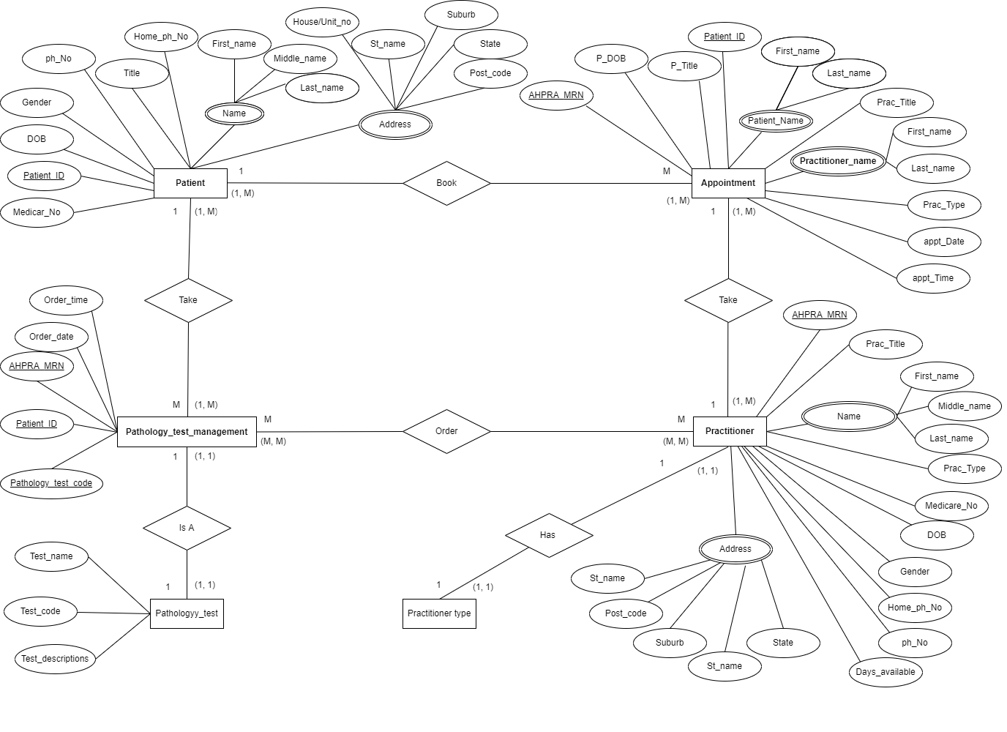

## Relational Data Model (RDM)

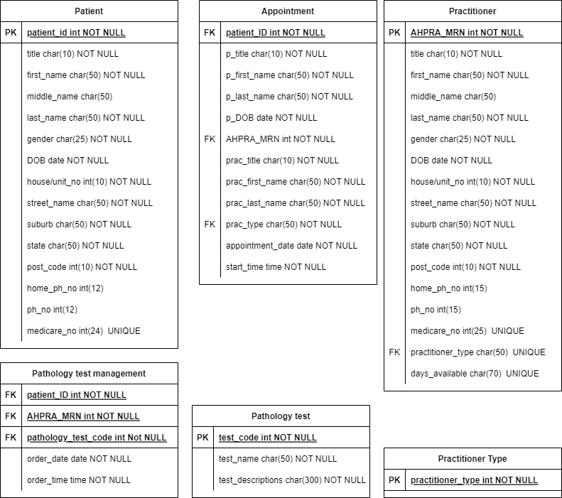

### Normalization

#### First Normal Form(1NF)

After applying the 1NF rules on the medical practice entities, we will achieve 1NF and the table will change to:

*Second Normal Form (2NF)*

In this step we need to determine which attribute(s) uniquely identify each instance of the entity.

In the above tables we have attributes which do not depend on the primary key so they have to be separated out or removed: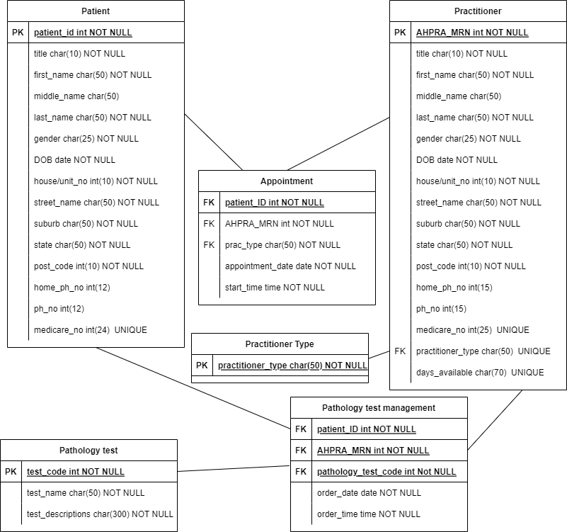

*Third Normal Form(3NF)*

All fields (columns) must not be determined by any column other than the primary key column, since there is no such field therefore, we can say it is already in 3NF.

*Forth Normal Form(4NF)*

There does not exist multivalued dependencies.

## Data dictionary

|  |  |  |  |  |  |  |  |  |
| --- | --- | --- | --- | --- | --- | --- | --- | --- |
| Table name | Attribute name | Content | Data type | Format | Range | Required | PK, FK or AK | FK referenced table |
| Patient | patient_id | Patient’s unique identifier | INTEGER | 123456 | 10000-99999 | Y | PK |  |
|  | title | Patient’s title. Eg, MR, MRS, DR | NVARCHAR(10) | Xxx |  |  |  |  |
|  | first_name | Patient’s first name | NVARCHAR(50) | Xxxx |  | Y |  |  |
|  | middle_name | Patient’s middle name | NVARCHAR(50) | Xxxx |  | Y |  |  |
|  | last_name | Patient’s last name | NVARCHAR(50) | Xxxx |  | Y |  |  |
|  | gender | Patient’s gender | NVARCHAR(50) | Xxxx |  | Y |  |  |
|  | date_of_birth | Date of birth of patient | DATE | dd/mm/yyyy |  | Y |  |  |
|  | house_number | Patient’s house/ unit number | INTEGER | XXXX |  | Y |  |  |
|  | street_ name | Name of street or road where patient reside | NVARCHAR(50) | Xxxxx |  | Y |  |  |
|  | suburb | Name of suburb where patient reside | NVARCHAR(50) | Xxxx |  | Y |  |  |
|  | state | Name of the state where patient reside | NVARCHAR(50) | Xxxx |  | Y |  |  |
|  | post code | Post code of patient’s residential address | INTEGER | XXXX |  | Y |  |  |
|  | home_phone_no | Patient’s home phone number | INTEGER | XXXXXXXX |  |  |  |  |
|  | mobile_phone_no | Patient’s mobile phone number | INTEGER | XXXXXXXXX |  |  |  |  |
|  | medicare_no | Patient’s medicare number | INTEGER | XXXXXXXX |  |  |  |  |
| Practitioner | AHPRA_MRN | Practitioner’s Medical practitioner number | INTEGER | 123456 | 10000-99999 | Y | PK |  |
|  | title | Practitioner’s title. Eg, MR, MRS, DR | NVARCHAR(10) | Xxx |  |  |  |  |
|  | first_name | Practitioner’s first name | NVARCHAR(50) | Xxxx |  | Y |  |  |
|  | middle_name | Practitioner’s middle name | NVARCHAR(50) | Xxxx |  | Y |  |  |
|  | last_name | Practitioner’s last name | NVARCHAR(50) | Xxxx |  | Y |  |  |
|  | gender | Practitioner’s gender | NVARCHAR(50) | Xxxx |  | Y |  |  |
|  | date_of_birth | Date of birth of Practitioner | DATE | dd/mm/yyyy |  | Y |  |  |
|  | house_number | Practitioner’s house/ unit number | INTEGER | XXXX |  | Y |  |  |
|  | street_ name | Name of street where Practitioner reside | NVARCHAR(50) | Xxxxx |  | Y |  |  |
|  | suburb | The suburb where practitioner reside | NVARCHAR(50) | Xxxx |  | Y |  |  |
|  | state | The state where Practitioner reside | NVARCHAR(50) | Xxxx |  | Y |  |  |
|  | post_code | Post code of Practitioner residential address | INTEGER | XXXX |  | Y |  |  |
|  | home_phone_no | Practitioner home phone number | INTEGER | XXXXXXXX |  |  |  |  |
|  | mobile_phone_no | Practitioner mobile phone number | INTEGER | XXXXXXXXX |  |  |  |  |
|  | Medicare_no | Practitioner medicare number | INTEGER | XXXXXXXX |  |  |  |  |
|  | practitioner_type | Type of the Practitioner | NVARCHAR(50) | Xxxxxx |  | Y | FK | Practitioner_type |
|  | days_available | Days of the week when Practitioner’s available | NVARCHAR(70) | Xxxxx, Xxxxxx, Xxxxx |  | Y |  |  |
| Appointment | id | Appointment unique identifier | INTEGER | 123456 | 10000-99999 | Y | PK |  |
|  | patient_id | Patient’s unique identifier | INTEGER | 123456 | 10000-99999 | Y | FK | Patient |
|  | p_title | Patient’s title. Eg, MR, MRS, DR | NVARCHAR(10) | Xxx |  | Y |  |  |
|  | p_first_name | Patient’s first name | NVARCHAR(50) | Xxxx |  | Y |  |  |
|  | p_last_name | Patient’s last name | NVARCHAR(50) | Xxxx |  | Y |  |  |
|  | p_date_of_birth | Date of birth of patient | DATE | dd/mm/yyyy |  | Y |  |  |
|  | AHPRA_MRN | Practitioner’s Medical practitioner number | INTEGER | XXXX |  | Y | FK | practitioner |
|  | prac_title | Practitioner’s title. Eg, MR, MRS, DR | NVARCHAR(10) | Xxx |  | Y |  |  |
|  | prac_first_name | Practitioner’s first name | NVARCHAR(50) | Xxxx |  | Y |  |  |
|  | prac_last_name | Practitioner’s last name | NVARCHAR(50) | Xxxx |  | Y |  |  |
|  | practitioner_type | Type of the Practitioner | INTEGER | XXXX |  | Y | FK | Practitioner_type |
|  | appt _start_time | Type of the Patient’s start time of appointment with a practitioner | TIME | 00:00 AM/PM |  | Y |  |  |
|  | appointment_date | Patient’s date of appointment with a practitioner | DATE | dd/mm/yyyy |  | Y |  |  |
|  | appt_end_time | Patient’s end time of appointment with a practitioner | TIME | 00:00 AM/PM |  | Y |  |  |
|  |  |  |  |  |  |  |  |  |
| Pathology_test_management | id | Pathology test order ID | INTEGER | XXXX | 10000-99999 | Y | PK |  |
|  | AHPRA_MRN | Practitioner’s Medical practitioner number | INTEGER | 123456 |  | Y | FK | practitioner |
|  | patient_ID | Patient’s unique identifier | INTEGER | XXXX |  | Y | FK | Patient |
|  | pathology_test_code | Pathology test identifier (test code) | INTERGER | XXXX |  | Y | FK | Pathology_test |
|  | order_date | The date that the test was ordered | DATE | dd/mm/yyyy |  | Y |  |  |
|  | order_time | The time that the test was ordered | TIME | 00:00 AM/PM |  | Y |  |  |
| **Pathology_test** | test_code | Pathology test identifier (test code) | INTERGER | XXXX |  | Y | PK | Pathology_test |
|  | test_name | Name of the test | DATE | Xxxxx |  | Y |  |  |
|  | test_description | Description | NVARCHAR(300) | Xxxxxx |  | Y |  |  |
| **Practitioner_type** | id | Practitioner type identifier | INTEGER | xxxxx |  | Y | PK |  |
|  | type | Type of practitioner | NVARCHAR(50) | Xxxxx |  | Y |  |  |



Crow’s Foot Entity Relationship Diagram (CF ERD)

